
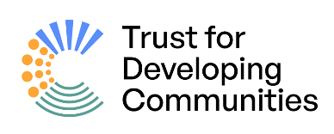


Community Research Resource Pack

A guide to doing community-led research for understanding and serving your wider community

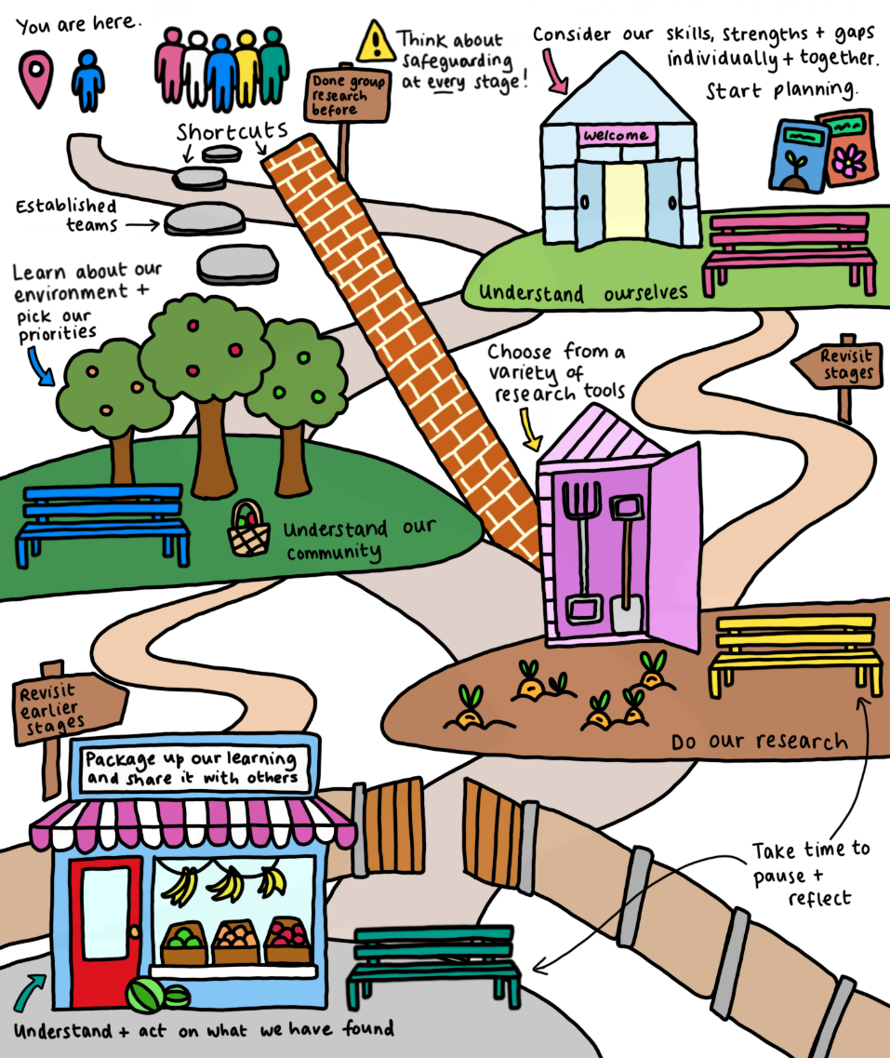

Written by:
Helen Johnson, University of Brighton, UK
Nicole Vann Monney, Trust for Developing Communities, UK

Resource Pack Contents

Introduction 3
Overview of the process 4
Diagram 1: The process 4
The 4 stages of research 5
Diagram 2: The 4 stages of research 5
Our research principles 6
Diagram 3: The 5 Systems 7
Understanding ourselves: How we’ll work together 8
Worksheet 1: Understanding our community group 9
Diagram 4: Understanding the systems affecting our community group 13
Understanding the wider community 16
Worksheet 2: Our current context 17
Diagram 5: Understanding the systems affecting our wider community 18
Worksheet 3: Finding other information 25
Doing our research 27
Understanding and acting on what we have found 35
Worksheet 5: Recording and analysing results 36
Worksheet 6: Turning our findings into action 37
About the authors 40
Copyright and funding 40

Introduction

This pack contains guidelines and resources to support community-led research. It includes suggestions of how you might think about your project, the types of questions you could ask, and how to put this into action.

Who is this pack for?
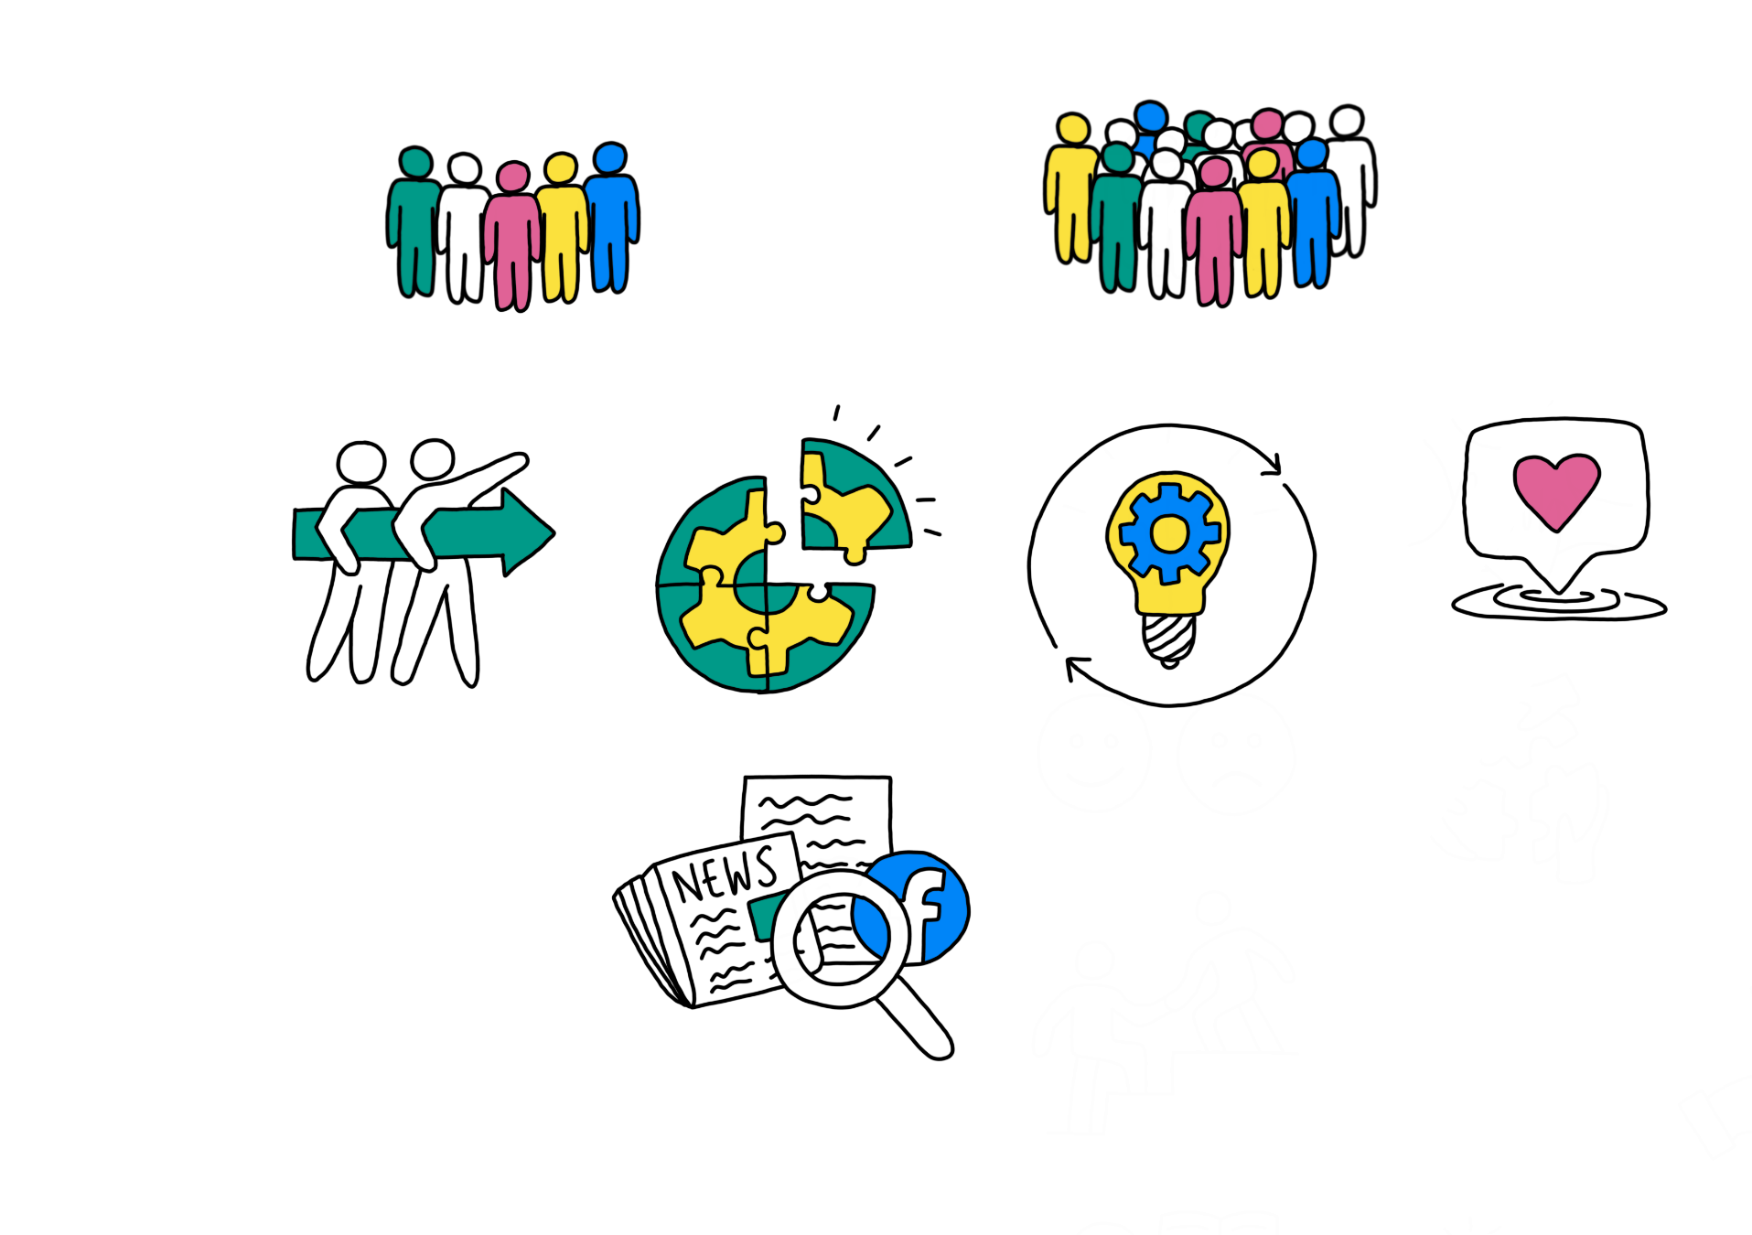
The pack is for community-led groups and organisations who want to find out more about their wider community, and how they can best be supported.

We will be using the term ‘community group’ to refer to the people carrying out the research.

We will use the term ‘wider community’ to refer to the larger group of people you want to support.

Your research might look at:
- How to change your group’s work, culture, values or practices and how to embed processes for continuous learning.
- The impact of your work, and how to explain your impact to others.
- Changes in your community group’s priorities or finding new ways to make changes.
- Something that needs action (such as partnership development or funding) and why this is needed.

You can choose:
- Which resource(s) you use and when.
- Who you invite to work with you.
- To change the resources to meet your needs.
- How much time you spend on this. Community research can be done over weeks, months or years, so choose a timeframe that works for you.
- To use, share and edit this pack, as long as you don’t make any money from this. If you share it, you must credit us (Helen Johnson and Nicole Vann Monney) and highlight any changes you have made.

This document is a simplified version of our Community Research Resource Pack. The original version is available here.

You are welcome to send us (the authors) any feedback or questions by email:
- Helen Johnson - h.f.johnson@brighton.ac.uk
- Nicole Vann Monney - nicolemonney@trustdevcom.org.uk

We hope you find this pack useful and wish you luck with your research!

Overview of the process

You can begin your research at any point in the process, depending on what you need and what you already know. If you are working together for the first time, we recommend you start with ‘understanding ourselves.’ If you are researching this topic for the first time, but are used to working together as a group, then you will probably want to start with ‘understanding the wider community’. If you already know a lot about each other and the wider community, you might want to start with ‘doing our research.’ You might also decide to skip some stages or work your way through the stages more than once.

Diagram 1: The process
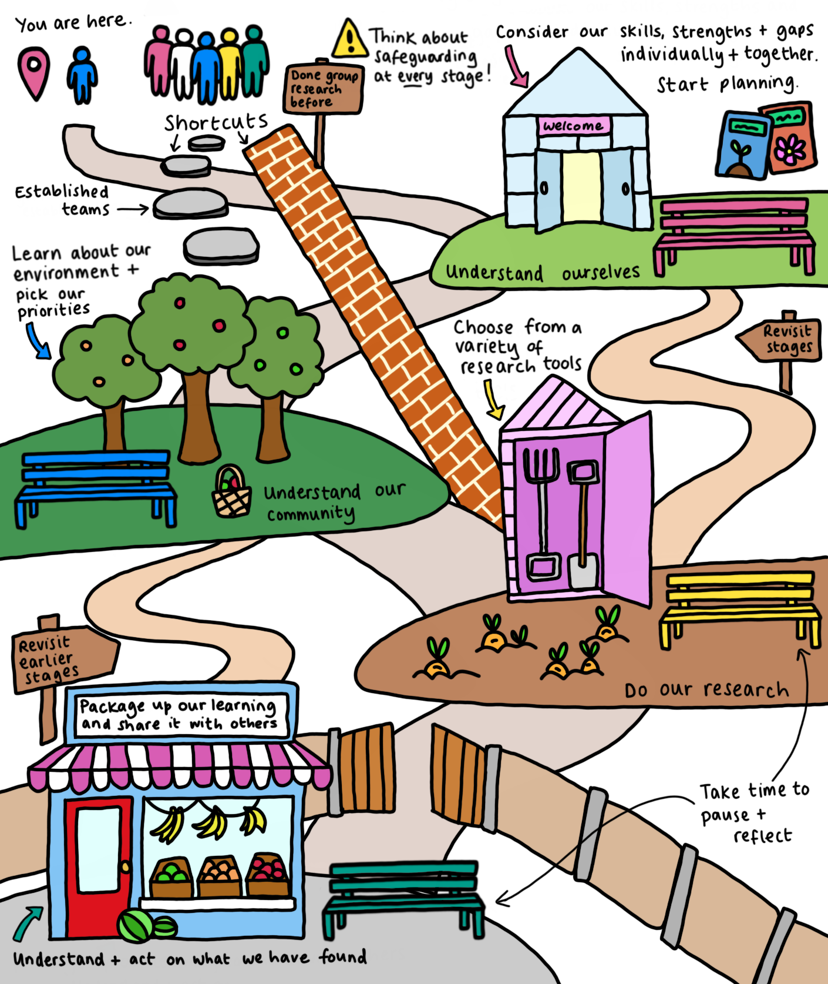

The 4 stages of research

Diagram 2 shows the 4 stages of research covered in this pack. Each stage consists of:
- An introduction explaining what the stage will help you to achieve
- Worksheets that guide you through the activities you need to carry out for that stage. Most of these are designed to be completed as a group, but there are some sections for you to complete individually.

Diagram 2: The 4 stages of research

- Establishing shared understanding
- Identifying skills, knowledge, experience and values within the team
- Assessing our capacity for doing community research
Understanding the wider community
Understanding and acting on what we have found
Doing our research
- Scoping the field
- Consulting the community
- Reviewing academic literature
- Identifying gaps
Understanding ourselves
- Sharing findings
- Supporting change
- Planning next steps
- Designing a study
- Learning about research methods
- Collecting and making sense of new data
- Getting feedback from the community

Our research principles

The materials in this pack are based on principles drawn from the idea of “everyday creativity,” which emphasises the creative activities that people carry out in their day-to-day lives.

The principles are:

Grassroots/ community-led  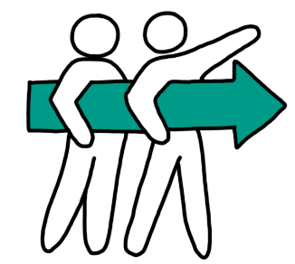 | Synergistic with existing practice (fits with how we do things already | Flexible and innovative  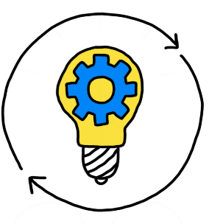 | Supports meaningful engagement and impact  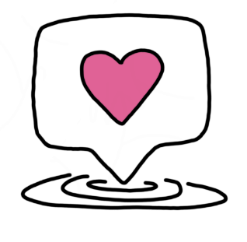

Our model recognises that people are affected by their environments. We can understand this in terms of 5 interconnected systems (see Table 1 and Diagram 3 below). Thinking about what these systems look like for your community group and wider community can help you make your research more impactful.

Table 1: The 5 Systems

Scientific term | What we call it | Examples
Microsystem | Immediate setting | This can include people and places, such as work, school, family and the neighbourhood.
Mesosystem | Connections | The interaction between 2 (or more) elements, such as school and family, or work and friends.
Exosystem | Indirect influences | Institutions and groups that indirectly affect the person, such as their partner’s workplace, local councils, community resources and charities.
Macrosystem | Bigger picture | Wider cultural, societal and political contexts, values, beliefs and laws
Chronosystem | Change over time | How the events in someone’s life can affect them over time.

Diagram 3: The 5 Systems

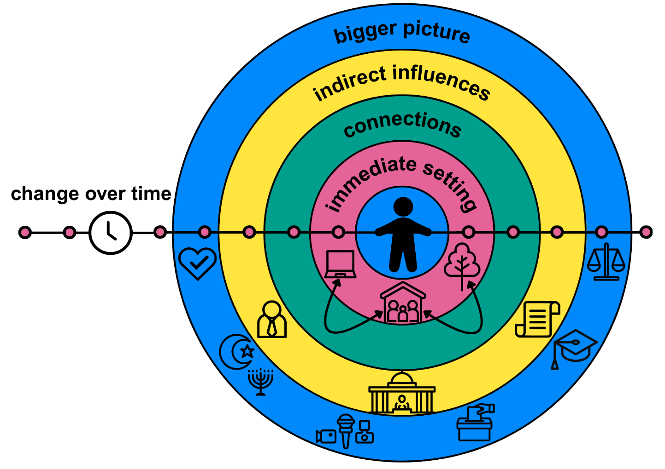


Understanding ourselves: How we’ll work together

This section will help you to:
- Understand your community group.
- Identify your individual and shared values.
- Explore your collective strengths, knowledge, experience and skills that will help you in your research.
- Identify any gaps in your knowledge or skills.
- Agree on your community group’s shared priorities

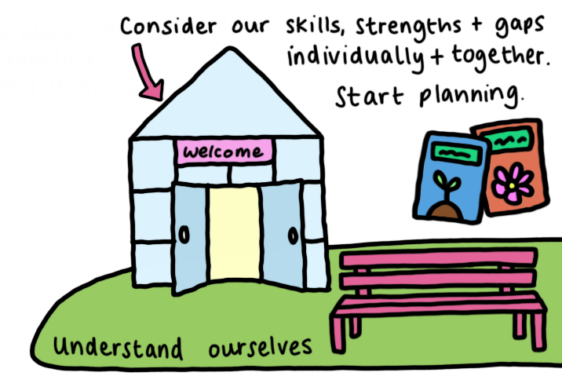

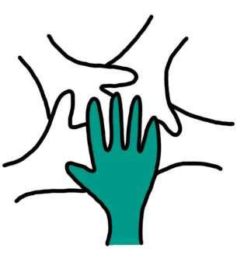
Worksheet 1: Understanding our community group
Complete Part 1 of this worksheet individually.

Part 1: About me
What is my role in my community group? What will I do? For example: lead sessions, take notes, find resources, or talk to other people in the wider community.
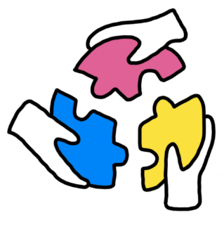

What is important to me? What do I value? For example: “What/who do I care about?”, “What do I think I/other people should be doing in/for the wider community?” or “Why is this important to me?”
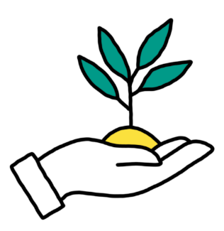
What am I good at? What skills do I have that might be useful? For example: communicating clearly, resolving conflicts, taking notes, or organising paperwork.
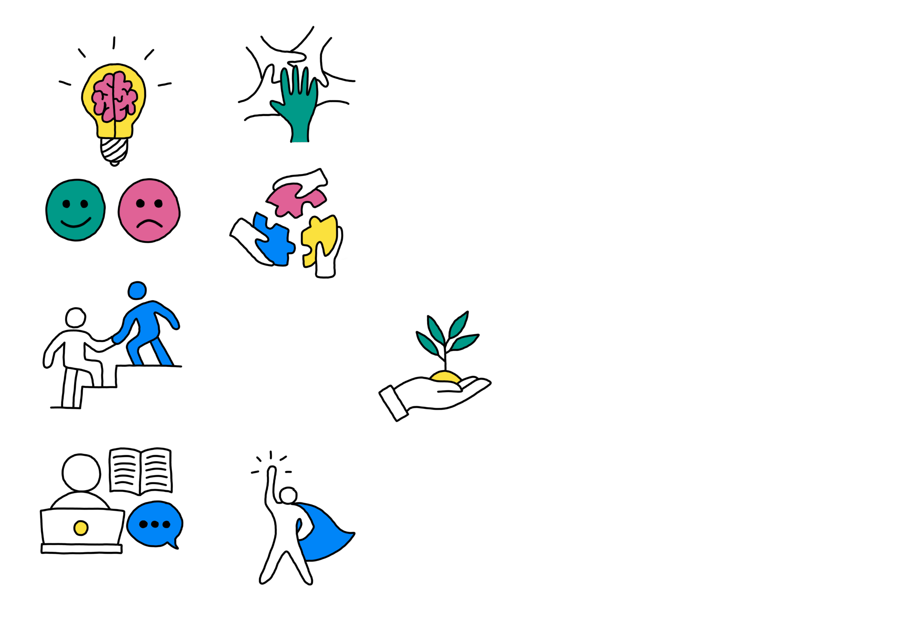
What does community research mean to me?
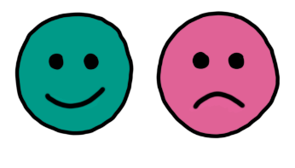
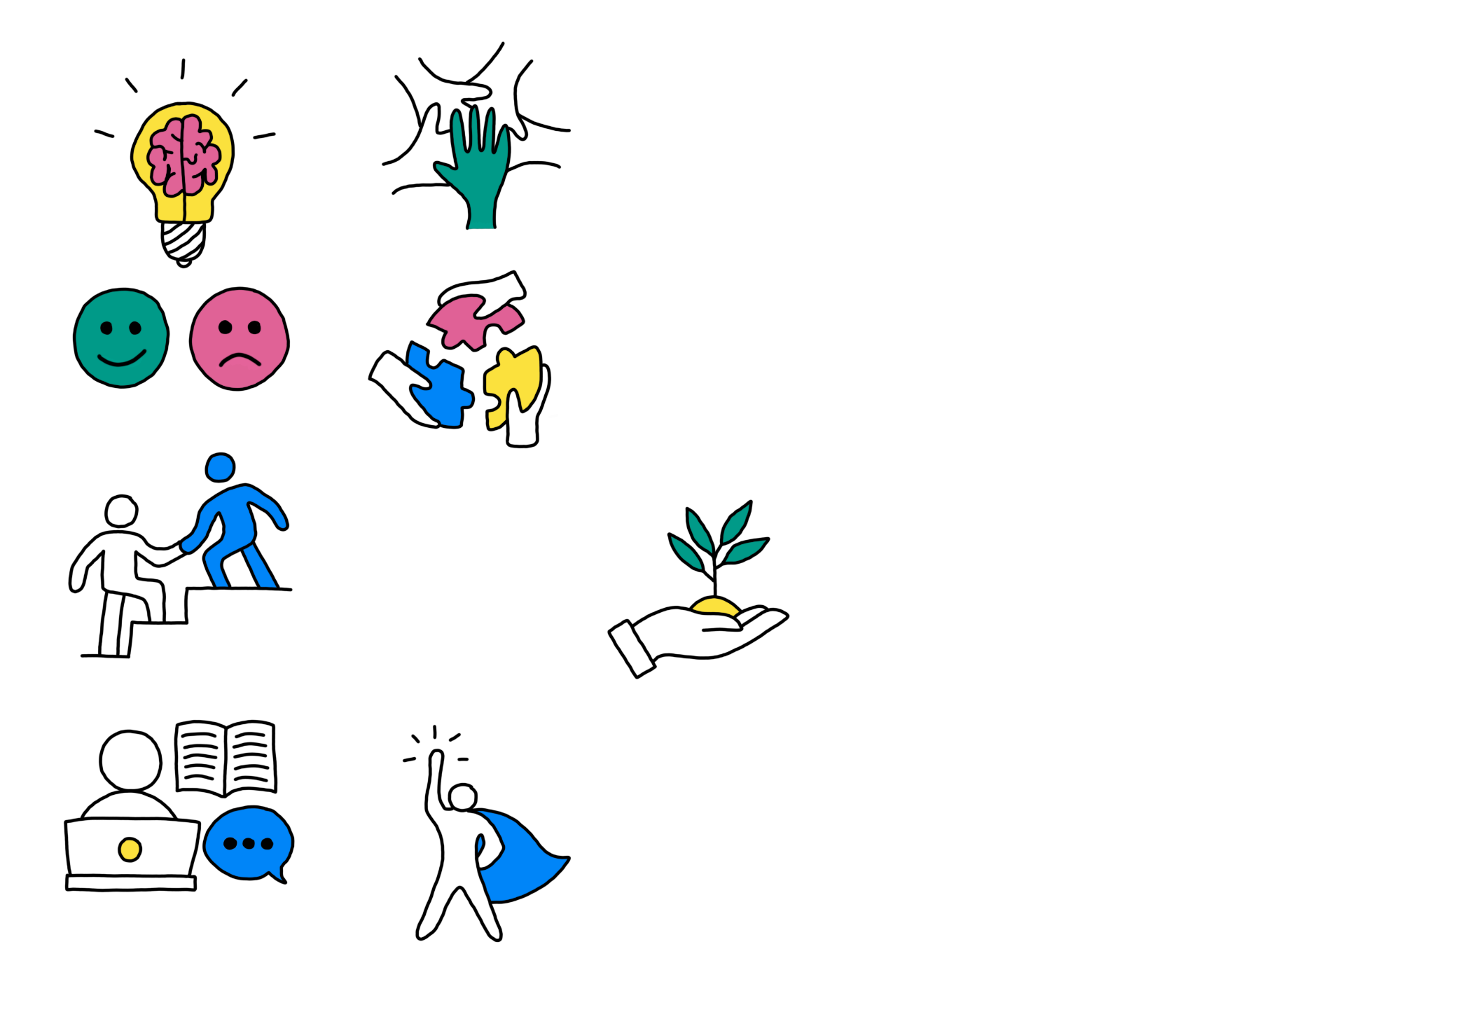
I want to do research with my wider community because…

For me, doing research means…

What support do I need? For example: enough time to read materials before meetings, frequent breaks, using a laptop to take notes, or step-free access to buildings.
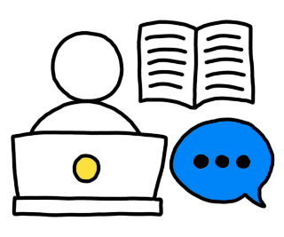

Part 2: About our community group
Answer the questions in Part 2 together, thinking about your responses in Part 1.

Start by completing Diagram 4. For this activity, we have replaced the central person with your community group. Think about what the systems that surround your group look like. What people, organisations, values and changes are likely to influence your work together? Focus on writing down the most important parts, rather than trying to list everything. Table 1 has more information about the 5 systems.

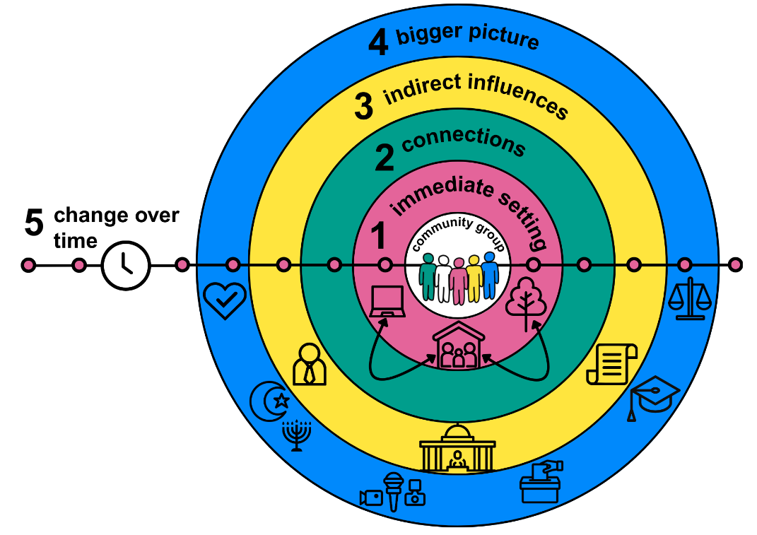
Diagram 4: Understanding the systems affecting our community group

- Immediate setting (such as family and friends)

- Connections (such as between neighbours and friends)

- Indirect influences (such as local governments or charities)

- Bigger picture (such as our cultural values, and values in the wider community)

- Change over time (such as government policy changes, or different times in the school year)

What is important to us as a group (our shared values)?
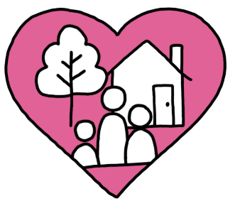
What are we good at and how can this help our community research?
What skills, knowledge and relationships do we already have that can help us? Your answers in Diagram 4 may help with this.
What are we worried about when doing community research? For example: having enough time to do the work, understanding academic jargon, or knowing how to use our findings to make a difference.
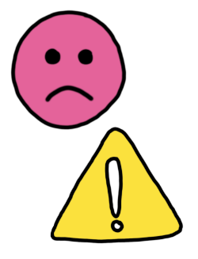
What do we need to do or learn? For example: finding a meeting space, learning more about data analysis, doing some training in making online questionnaires, or finding out who can make a difference for the wider community.
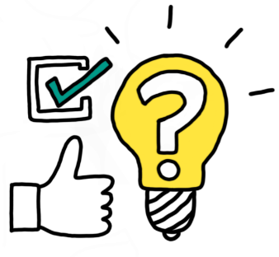

Which organisations or resources can help us with our research, training and additional learning? Add specific names and places where you can, including organisations and online resources.
Free training providers include the Trust for Developing Communities (www.trustdevcom.org.uk), University of Reading (https://research.reading.ac.uk/participation-lab/home/), Scottish Community Development Centre (SCDC) (https://www.scdc.org.uk/training), and Institute of Voluntary Action Research (IVAR) (https://www.ivar.org.uk/connecting-health-communities/)

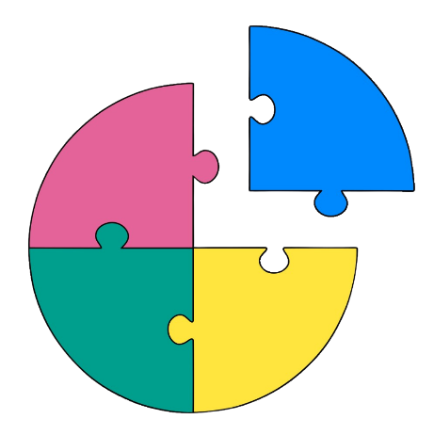
Understanding the wider community

This section will help you to gather information about:
- The environments you are working in.
- The things that are important to your wider community, and how you know this.
- The priorities you want to achieve for (and with) your wider community.
- How you will achieve these priorities, and who can help you.
- Any gaps in your knowledge.
- How you will find any missing information.
- How you will know if you have achieved your goals.

While working on this section, you may think of (more) information you can add to Diagram 4. It may help to reference and update your copy of Diagram 4 whilst you do this section.

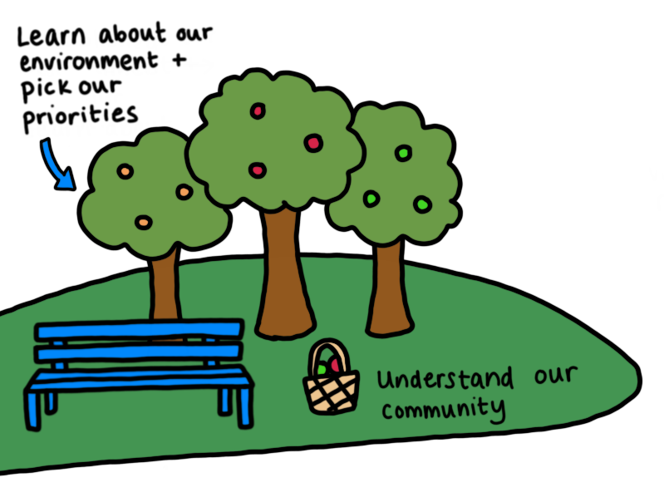

Worksheet 2: Our current context

Part 1
Working individually, complete Diagram 5 (below), thinking about your wider community. The inner circle represents an individual in this community. You can think of a particular individual or several different people for this. Consider what the systems that surround these people look like. What people, organisations, values and changes are likely to affect their lives? Focus on what is particularly important in each system, rather than trying to list everything. Table 1 has more information about the 5 systems.

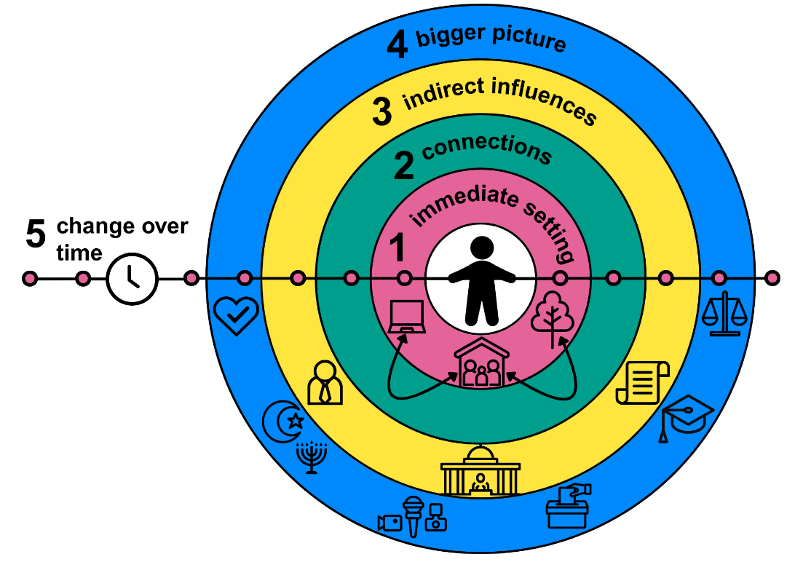
Diagram 5: Understanding the systems affecting our wider community

- Close environment (such as family and friends)

- Interactions (such as between neighbours and friends)

- External powers (such as local governments or charities)

- Culture (such as our cultural values, and values in the wider community)

- Life experiences (such as government policy changes, or different times in the school year)

Part 2
Working together as a group, use your responses to Part 1 to complete the boxes below.
What are our community group’s purpose and aims?
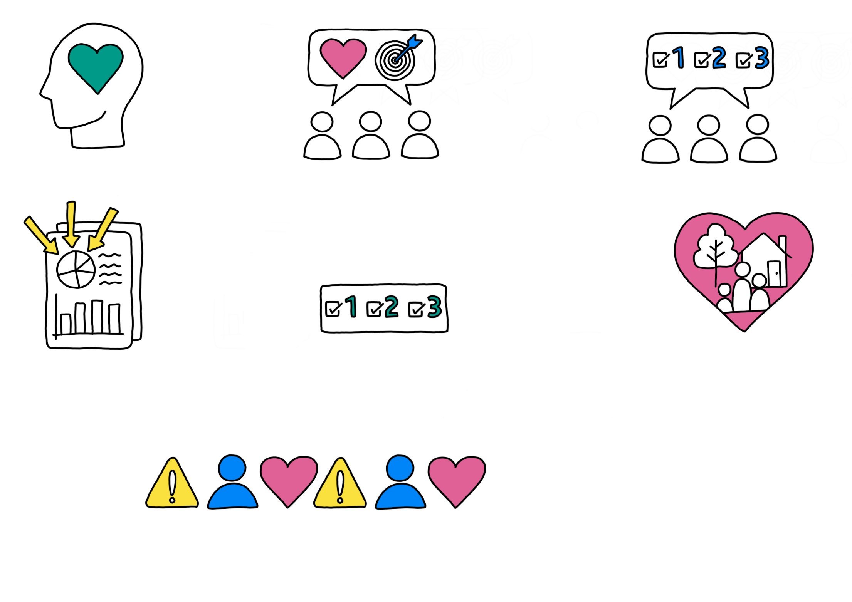

What do we know about our wider community?
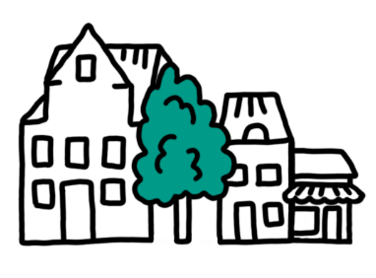

What is working well now?
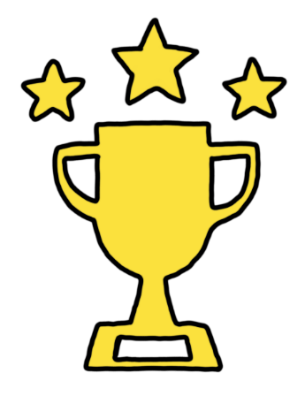

How do we know it is working? Who and what information has told us this? Are we missing any people or evidence?
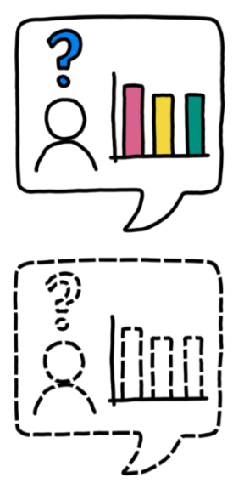

What policies or legislation might affect our work?
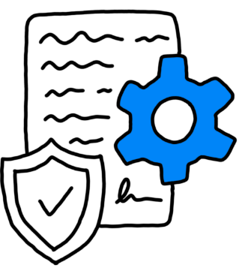

Part 3
Answer this part with as much detail as you can. Leave gaps if needed and add new information later.
What do we think is important for our wider community? Looking at our answers in Parts 1 and 2, what stands out?
Who and what evidence has told us this? Are we missing any people or information?
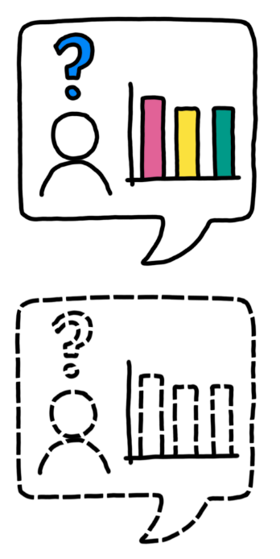

What do we want to achieve?
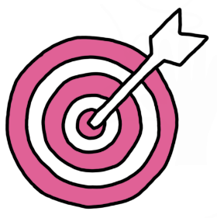 | Aim 1 | Aim 2
 | Aim 3 | Aim 4
Who should be involved?
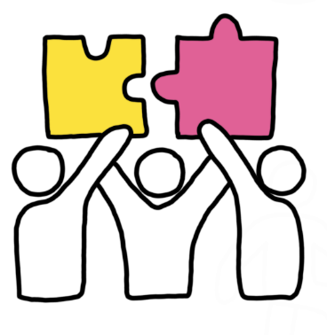

Part 4
Summarise what you have discussed so far in this table. Think about:
- What your wider community wants (priorities)
- Who should be involved, and what you need to find out (who/what we need)
- What you can do to change things (what we will do)
- Aims for your community group (what we want to achieve) and
- How you will know if you have done this (success measures)
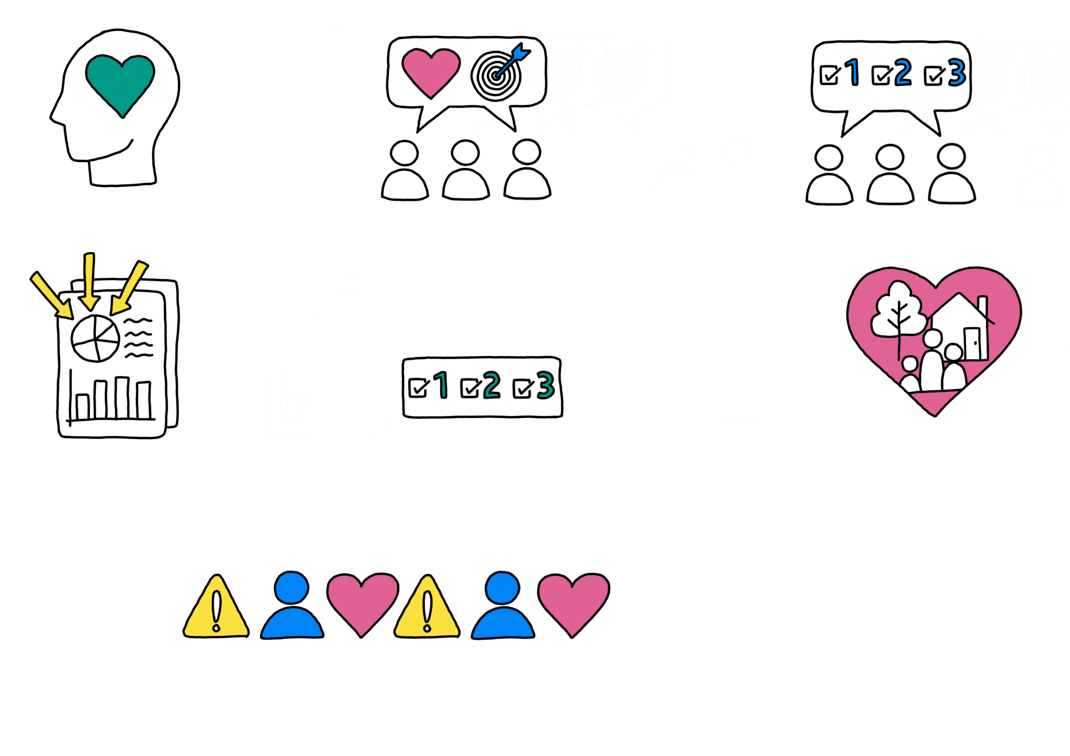
Priorities | Who/what we need | What we will do | What we want to achieve | Success measures

Worksheet 3: Finding other information

Now that we have our priorities, what else do we need to know that can help us address them?

Think about other places you might find evidence of these issues and write them under “How and why do we know this to be true?”. These could include: an activity you have done before, something you’ve noticed in the media, or things you’ve heard from local residents (in person or on social media). You may also want to find out what other people have written (for example, in academic papers) or look at other projects happening elsewhere. Once you have done this, complete the other 2 columns.

What is the issue? | How and why do we know this to be true? | Which priority does this relate to?

What do we still need to know? What information is missing?
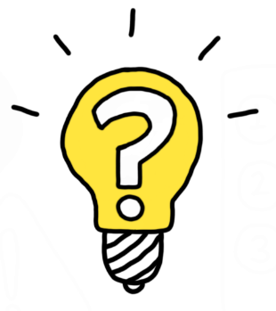


Doing our research

As part of your research project, you need to decide where and how to look for evidence. Your decision will depend on the amount of time you have, how confident you feel with different methods, and the kinds of questions you want to answer.

This section will help you to:
- Choose the questions you want to answer.
- Choose the methods you will use to gather your evidence.
- Decide where you will collect your evidence.
- Decide how you will make sense of what you have found, and who will do this.
- Think about how you can make sure everyone feels included and safe.

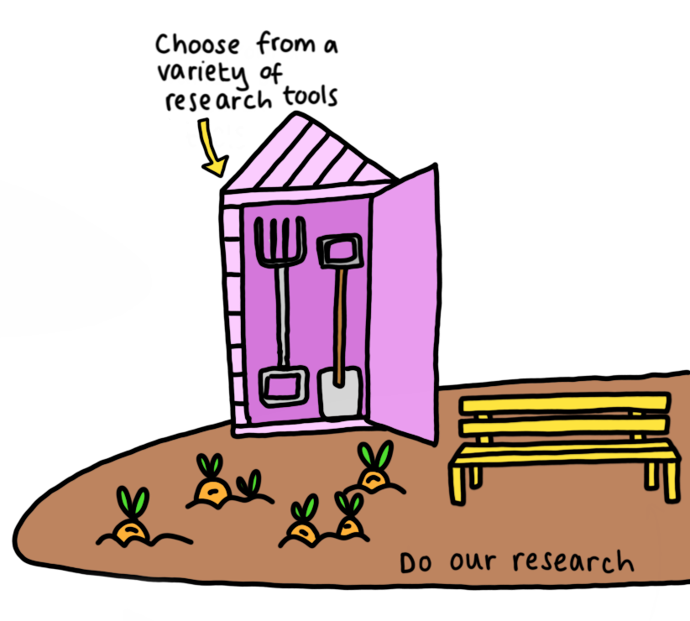
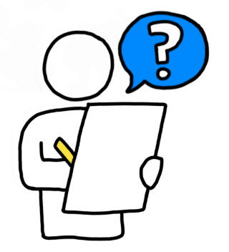
Worksheet 4: Designing a community research project

Part 1: Choosing your research methods
Complete the boxes below. We have provided example responses in each, based on a fictional study.
What are our research priorities? What do we want to achieve?
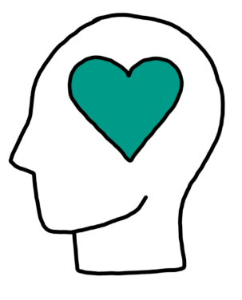
Example: To get better support in schools for neurodivergent children (including those with autism, dyslexia and ADHD).
What question(s) do we want to answer?
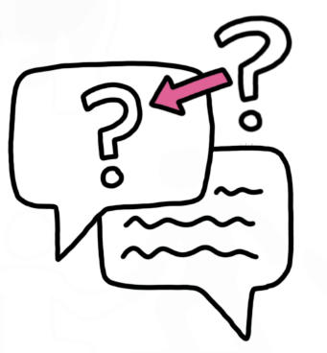
Example: What are neurodivergent children’s experiences in school? What support do they need? How could this be put in place?
We recommend capturing evidence in more than 1 way, as this will give you access to a greater variety of perspectives and help you identify important findings.

Some methods you use could include:
- Questionnaires. These can be helpful if you want to compare between groups, contexts or time periods or create graphs or charts. You can also ask people to write short reflections to give you more depth and detail.
- Interviews or focus groups to talk to people about their experiences. You could turn their stories into case studies and/or look for patterns across people’s experiences.
- Arts-based methods, such as writing poems, creating a video about people’s experiences or creating a map of the local area that reflects how people feel about or interact with different places.
What data collection method(s) will we use? How will we gather evidence?
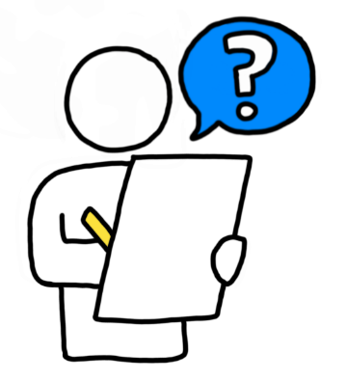
Example: We will interview parents about their children’s experiences in school. We will ask teachers and teaching assistants to complete questionnaires about the support they offer, and what affects this support.

Once you have collected your evidence, you can analyse it to look for any patterns. These could include:
- The most common answers to your questionnaire
- People talking about similar things during interviews, and/or
- The same images or words appearing in people’s artwork or poems.

It is also important to look for variation. For example, if some people have different views and experiences to others.

More information about online resources relating to data analysis methods can be found in the Further Resources section of the full pack available here at https://bit.ly/4kMU3Dw.
How will we make sense of (analyse) the evidence?
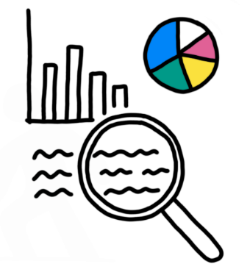
Example: We will transcribe (type up what was said) and look for key themes across the interviews (thematic analysis). We will use descriptive statistics to look for common responses and interesting differences in the questionnaires (such as averages, most common answers, and comparing the responses from teachers and teaching assistants).

Part 2
Where will we collect our evidence? For example: how you will find participants, who your participants will be, and how many participants you want to speak to.
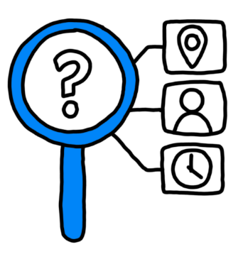
Example: We will write to all local schools and ask them to share the questionnaire with their staff. We will put up posters in local schools and community centres, and ask charities to share a post online, to find parents to interview. We will try to get responses from at least 30 teaching staff and 100 parents.

Who will collect and analyse the evidence? This can be 1 person, several people, or all members of your community group.
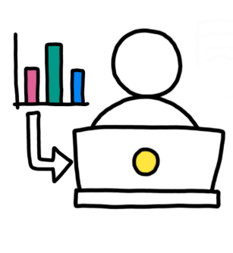

Do they know how to do this? If not, where and how will we learn to do this?
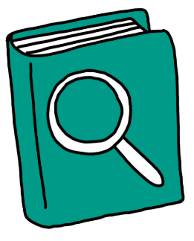
Example: We need to find out more about interviewing. We will learn about this by practicing writing interview questions and interviewing each other.

Part 3: Safeguarding and Inclusion
You should make sure everyone feels included and safe during your research project.

This can be affected by different experiences and identities, including:
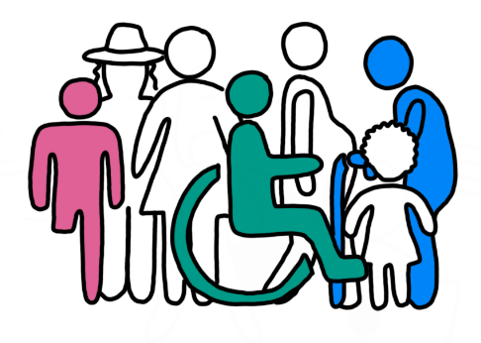
- Age
- Gender
- Sexuality
- Race
- Religion
- (Dis)ability and neurodivergence
- Language
- Social class
- Income

Think about everyone who may be involved in your project, including your community group and the wider community, and how you can keep them safe. Then answer the questions below.
What does “safety” mean to you?
How can we make sure all participants feel safe (able to speak up and contribute without being judged or harmed in any way)? What can’t we control?
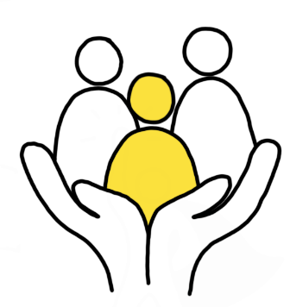

Inclusion is strongly linked to safeguarding. If people don’t feel safe, then they are unlikely to be included.
What does “inclusion” mean to you?
What can we do to make sure everyone feels included and safe in our project? Is there anyone we can’t include at the moment?
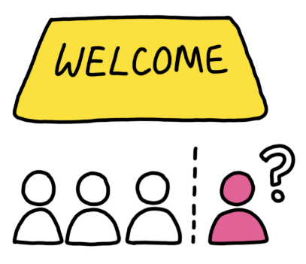


What could go wrong, or who could be hurt? Add any potential issues related to safety and inclusion, and how you will respond to these in the table below.
What could go wrong? | How could we stop this happening? | What will we do if it happens?
Once you have completed this table, check your plan and methods to make sure they meet your inclusion and safeguarding priorities. Update them if needed before you continue.


Understanding and acting on what we have found

This section will help you to:
- Record what you have found out.
- Assess the quality of your evidence.
- Decide who you need to share your research with.
- Choose what to share with each person, group or organisation, and how you will do this.
- Decide if you still need to take further action.



Worksheet 5: Recording and analysing results

Complete this worksheet together once you have gathered and made sense of your evidence. There is a fictional example to help you at the top.

Research question | What we found out | How do we know this?  What kind of evidence does this come from (for example, interview quotes or questionnaire statistics)? What bits of evidence are particularly interesting or revealing? You can add links or references to your evidence as needed.
Example: What are neurodivergent children’s experiences in school? | Many local children with autism and ADHD are poorly supported in school. | 80% of school teaching staff responding to the questionnaire said they didn’t have the resources they needed to support these children properly.
 |  | From our questionnaire, 65% of primary school teachers and 53% of secondary school teachers said that neurodivergent students were excluded from their classroom “often” or “very often”.
 |  | Many parents of autistic children said that getting support for their child was a “fight”. (See table of interview quotes, pages 3-4).

Worksheet 6: Turning our findings into action

Part 1
Who do we need to share our findings with? Include all participants, anyone affected by the research, and people with the power to change the issues you care about.
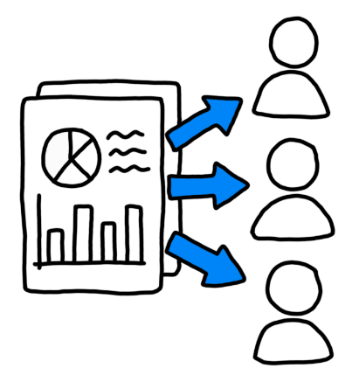

What are the most important things we need to tell these groups? Your answers in Worksheet 5 can help answer this. These things may vary for different groups.

What are the best ways to share this information? Think about how, when and where.
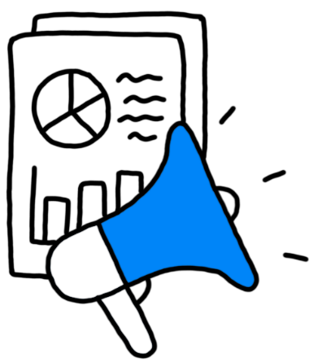

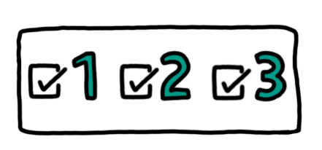
Part 2
Add your starting priorities to the table below, with reference to Part 1 of Worksheet 4. You can also add any new priorities identified during your project.

Priority | Have we addressed/resolved this? | Is there anything we still need to do? Remember that you can work through any part of this pack again to help you with this.

About the authors

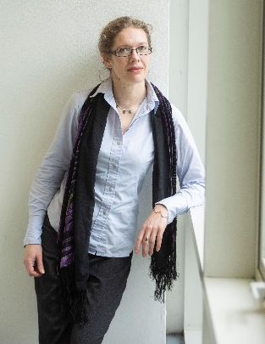
Helen Johnson
Dr Helen Johnson is a Principal Lecturer in Psychology, Co-Director of the Centre for Arts and Wellbeing at the University of Brighton and Principal Investigator for the Arts and Humanities Research Council (AHRC) Everyday Creativity Research Network. Her work focuses on participatory and arts-based research, applications of the arts in enhancing health and wellbeing, and exploring spoken word communities and practices. She is the founder of the Collaborative Poetics method, which combines these interests, and a key contributor to the University of Brighton’s Community University Partnership Programme. She is also a spoken word artist and Stage Manager for Glastonbury Festival’s Poetry&Words stage.

Contact Helen by email: h.f.johnson@brighton.ac.uk
Visit Helen’s website: www.helenjohnson.co.uk


Nicole Vann Monney
Nicole Vann Monney is the Co-Production Manager for the Trust for Developing Communities. A highly skilled development worker, with achievements spanning from executive and strategic leadership roles, program building and management, to frontline delivery and casework. Nicole has extensive experience working with communities disproportionately affected by social and economic inequality, is committed to principles of social justice and social equity and fundamentally believes that people are the experts in their own lives. Nicole is a member of the Brighton and Sussex Medical School ‘Time for Autism’ Review Group and a champion for neurodivergence and autism.

Contact Nicole by email: nicolemonney@trustdevcom.org.uk

Copyright and funding

This pack is a shorter, more accessible version of the first edition ‘Community Research Resource Pack’ (published in 2024) which is available here at https://bit.ly/4kMU3Dw. The Pack was made possible with funding from the Arts and Humanities Research Council (AHRC) Impact Acceleration and Policy and Participation funds, administered through the University of Brighton’s Community University Partnership Project, and is licensed under CC BY-NC-SA 4.0. To view a copy of this license, visit http://creativecommons.org/licenses/by-nc-sa/4.0/

Based on the ecological systems theory created by psychologist Urie Bronfenbrenner in 1979.

